Case 5-Asia-China-Hongshan-Bi Disc-3 Notch-Jade-Rust-3500-2200 BCE

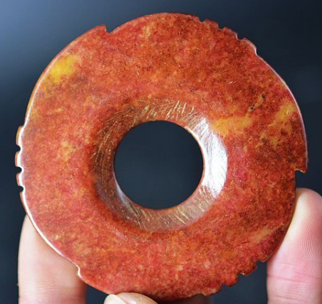 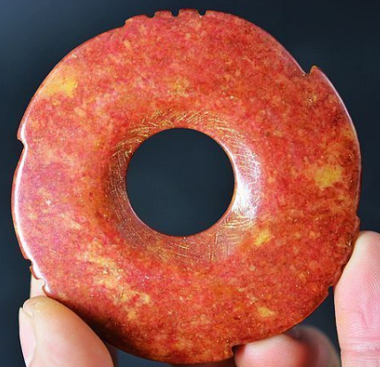

Figs. 1-2. China-Hongshan-Bi Disc-3 Notch-Jade-Rust-3500-2200 BCE

**Case no.: 5**

**Accession Number:**

**Formal Label:** China-Hongshan-Bi Disc-3 Notch-Jade-Rust-3500-2200 BCE

**Display Description:**

**LC Classification:**

**Date or Time Horizon:** 3500-2200 BCE

**Geographical Area:** Liaoning

**Map:**

**GPS coordinates:**

**Cultural Affiliation:**

**Media:**

**Dimensions:**

**Weight:**

**Condition:**

**Provenance:**

**Discussion:**

**References:**